# **Test Web App – Screenshots**

1. **Dashboard**

1. **Tests**

1. **Solutions**

1. **Test (blank)**

1. **Test (answered)**

1. **Review Test**

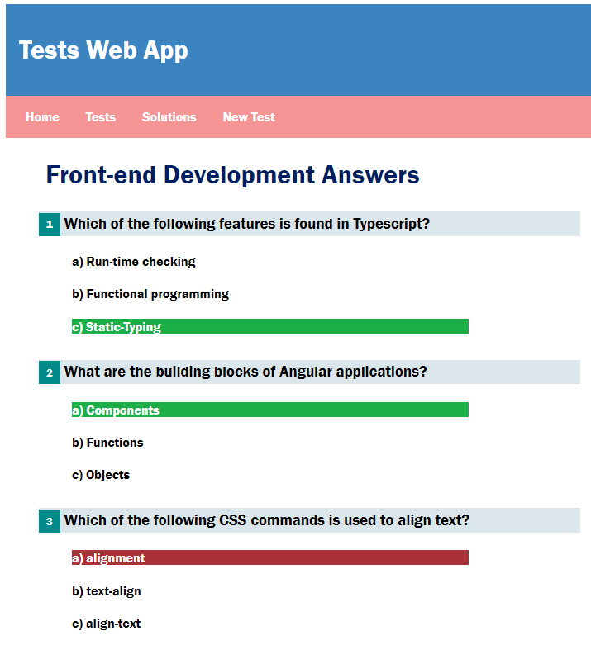

1. **Solution**

1. **New Test (Blank)**

1. **New Test (Filled)**

